Design Document for Session Management and Authentication for AgentCore Gateway
Proposed Solution 1 (MCP wrapper (Auth+agentcore gateway forwarding) client forward to mcp wrapper first)
Assumed requirements:
- If a client attempting to access the gateway is not authorized, the request must be blocked immediately, preventing it from reaching the gateway.
- If a user remains inactive for a defined period, the session will expire. Any subsequent attempt to use the same session without properly initiating a new conversation must be rejected.

Overview
This document describes the design for implementing session management and JWT authentication validation for a conversational AI system in the insurance domain. The goal is to ensure that every request coming from Gemini Enterprise through the MCP client is authenticated and associated with a valid session before the request reaches the Orchestrator Agent and downstream BCBSM Agents
The solution introduces an MCP-based wrapper that combines both the authentication service and the Amazon Bedrock AgentCore Gateway functionality. This wrapper acts as a unified interface that first performs authentication and session validation before forwarding requests to the underlying gateway. Within this wrapper, a Python-based authentication service validates the Okta-issued JWT token, manages sessions keyed by MemberID + conversationId, enforces idle timeout rules, and detects token refresh events. Only after successful validation does the wrapper forward the request to the AgentCore Gateway, which then routes the request to the Orchestrator Agent and the downstream BCBSM Agents
Importantly, this design keeps the client interaction consistent. Gemini MCP interacts with the MCP wrapper as a single endpoint, while the wrapper internally coordinates authentication validation and gateway invocation.
Sequence Diagram
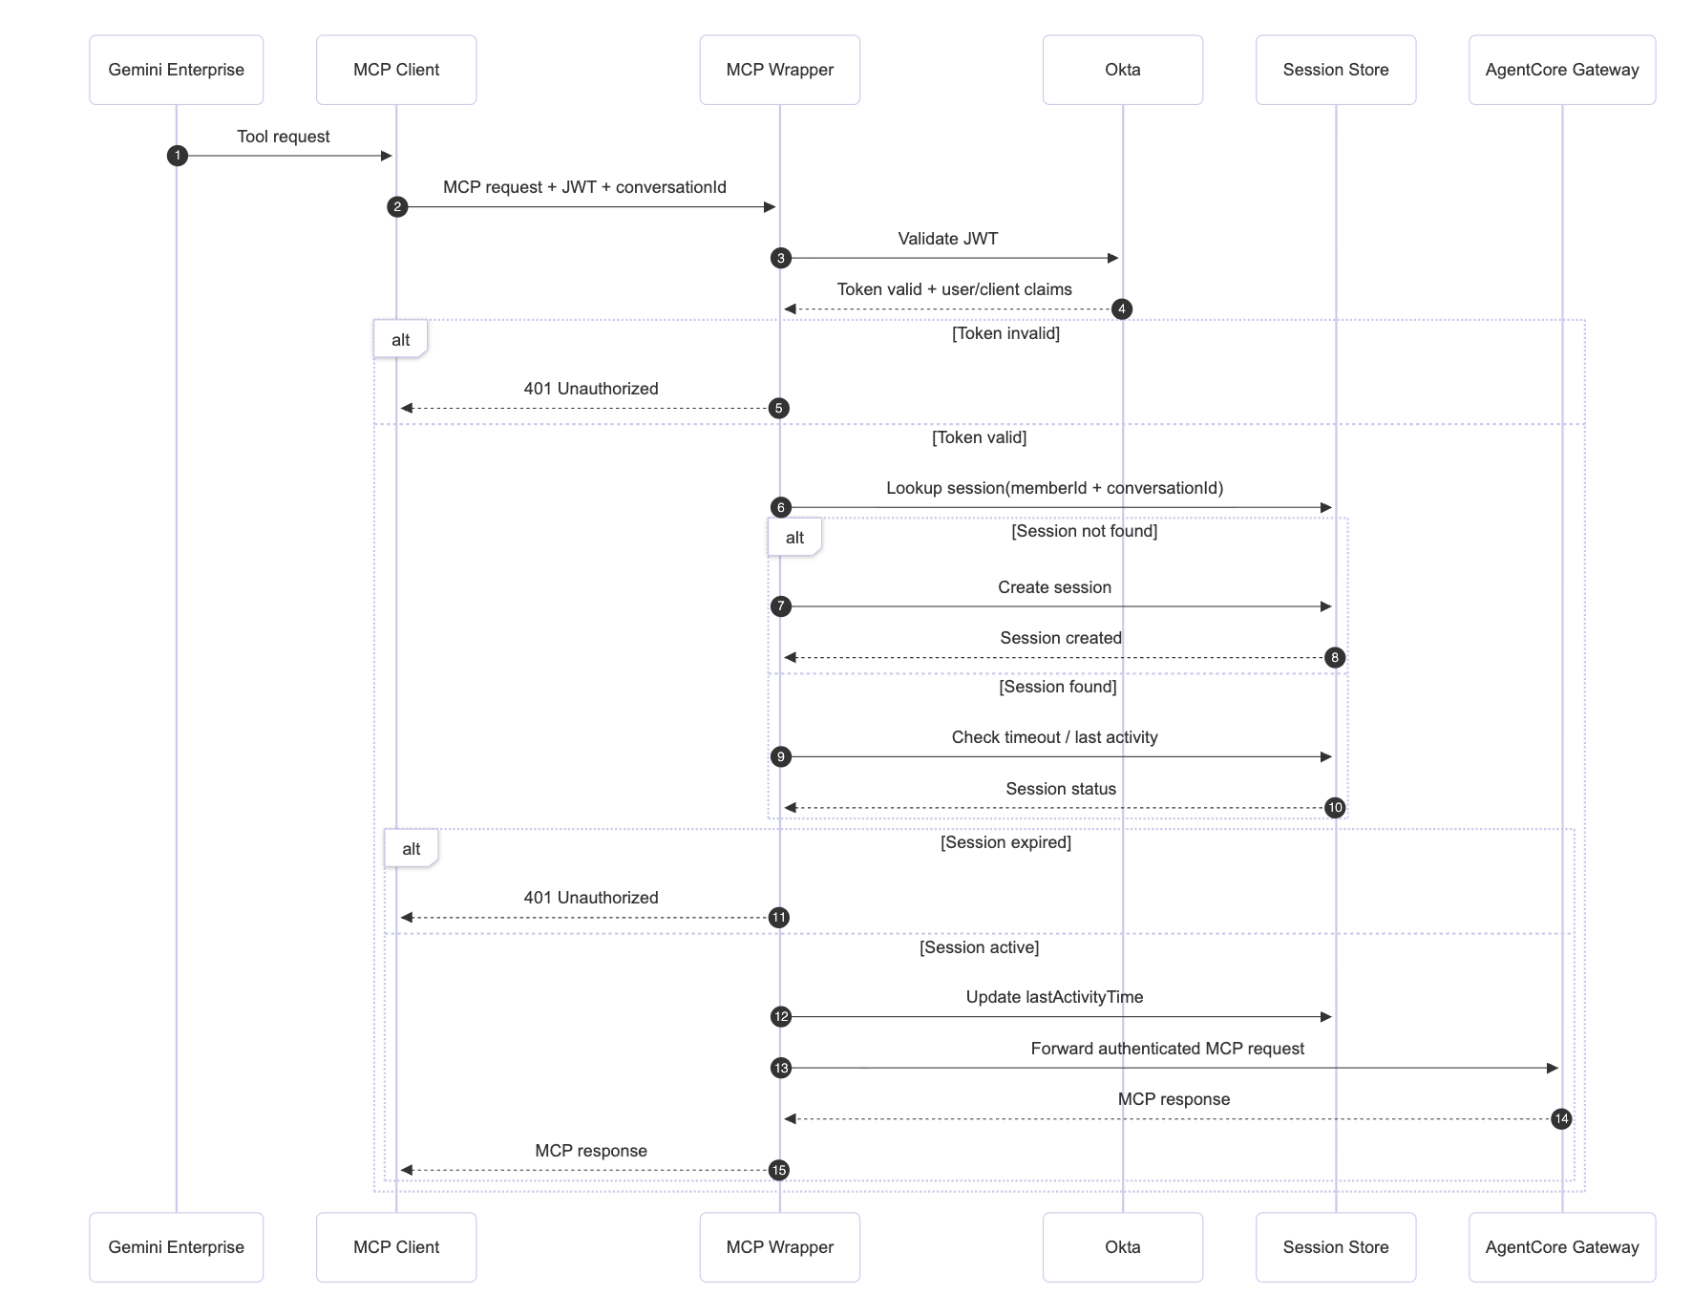
Design Objectives
The proposed solution is designed to achieve the following key objectives to ensure secure, reliable, and controlled access to the backend orchestration services.
- Secure Authentication
Every incoming request must be authenticated using Okta OIDC JWT access tokens. The client application is responsible for generating a unique cryptographic keypair (private and public keys) and obtaining a JWT access token from Okta using the appropriate OAuth/OIDC flow: Authorization Code flow when acting on behalf of a user, or Client Credentials flow when acting as a machine. The client retains the private key locally and uses it to sign each request to the MCP endpoint, with the signature covering request-specific data such as the HTTP method, URI, timestamp, and body. The client’s public key is pre-registered with the MCP server (or stored in a trusted backend) and is used to verify the signature. On the MCP wrapper/server side, each request is validated thoroughly. The wrapper first verifies the JWT signature using Okta’s JWKS to ensure the token was legitimately issued and performs standard token checks by validating the issuer (iss), audience (aud), and expiration (exp). To enforce client binding, the wrapper validates requests using the client signature and the pre-registered public key, ensuring that only the legitimate client application could have sent the request. Additionally, client-related claims in the token, such as cid and optionally scopes, are checked against a pre-approved allowlist of trusted clients. This approach ensures that the user identity is validated by the Okta access token and that the client application is proven to possess the private key, preventing token replay or misuse by unauthorized clients.
- Session Management
The session management design uses Redis as a centralized, low-latency store where each conversation session is tracked with a key in the format MemberID :conversationId and fields such as lastActivity, tokenHash, and createdAt; on every request, the wrapper checks whether the session exists, creates it for first-time requests, validates that idle time has not exceeded the configured threshold for example 10 minutes, updates lastActivity for active sessions, and resets key TTL so inactivity automatically expires sessions, while also detecting refreshed tokens by hash change to keep session continuity without storing raw tokens.
- Idle Timeout Enforcement
To improve security and resource management, sessions are subject to an idle timeout policy. If a session remains inactive for more than 10 minutes, it is considered expired. Any subsequent requests associated with the expired session will be rejected, requiring a new authenticated session to be established.
- Token Refresh Detection
The system is capable of detecting when a client provides a refreshed JWT token during an active session. This is achieved by computing and comparing a hash of the incoming token with the previously stored token hash in the session record. If a change is detected, the session record is updated to reflect the new token while preserving the session continuity.
- Gateway Protection
A critical objective of the design is to ensure that only authenticated and valid sessions are permitted to reach the Amazon Bedrock AgentCore Gateway. The MCP wrapper performs all authentication and session validation checks before forwarding requests to the gateway, effectively preventing unauthorized or expired requests from reaching the orchestration layer.
Proposed Solution 2(Validation mcp target )
Needs header to be propagated using interceptor lambda

Ah, got it — thanks for clarifying! So the flow is:
- The client talks to AgentCore Gateway.
- The AgentCore Gateway is configured to propagate headers to the MCP target.
- The MCP target contains Python middleware that does authentication/session validation.
- Once validated, the MCP target forwards the request to the Orchestrator Agent and downstream BCBSM Agents.
Let me rewrite Proposed Solution 2 accordingly.

Proposed Solution 2 (Validation at MCP Target via Middleware)
Assumed requirements:

If a client attempting to access the gateway always point toward agent core gateway

Overview
This design describes session management and JWT authentication validation for the conversational AI system in the insurance domain, with validation performed at the MCP target instead of the client or wrapper.
In this approach, the client application sends requests to the AgentCore Gateway, which is configured to forward all request headers (including JWT, client signature, and metadata) to the MCP target. The MCP target hosts Python-based middleware that performs:
- JWT validation using Okta-issued tokens.
- Session management keyed by MemberID:conversationId.
- Idle timeout enforcement.
- Token refresh detection.
Only after successful validation does the middleware forward requests to the Orchestrator Agent and downstream BCBSM Agents. The AgentCore Gateway acts as a transparent forwarding layer, ensuring the MCP target is responsible for security enforcement.
This design keeps the client interaction consistent while centralizing authentication and session validation at the MCP target.

Sequence Diagram

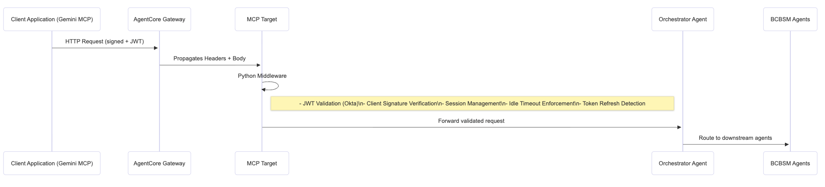

Secure Authentication

Every incoming request must be authenticated using Okta. The client application is responsible for generating a unique cryptographic keypair (private and public keys) and signing each request it sends. The client obtains a JWT access token from Okta using the appropriate OAuth/OIDC flow: the Authorization Code flow when acting on behalf of a user, or the Client Credentials flow when operating in a machine context. Once the client request, signed and carrying the JWT, reaches the AgentCore Gateway, the gateway forwards both the signature and token to the MCP target. At the MCP target, a Python-based middleware performs thorough validation. This includes verifying the JWT signature against Okta’s JWKS, checking standard claims such as issuer (`iss`), audience (`aud`), and expiration (`exp`), and enforcing client binding by validating the request signature using the pre-registered public key. Additionally, client-specific claims, including `cid` and optional scopes, are verified against a trusted allowlist. This layered validation ensures that only legitimate clients with valid JWTs can access the orchestration layer.

Session Management
The session management design uses Redis as a centralized, low-latency store where each conversation session is tracked with a key in the format MemberID :conversationId and fields such as lastActivity, tokenHash, and createdAt; on every request, the wrapper checks whether the session exists, creates it for first-time requests, validates that idle time has not exceeded the configured threshold for example 10 minutes, updates lastActivity for active sessions, and resets key TTL so inactivity automatically expires sessions, while also detecting refreshed tokens by hash change to keep session continuity without storing raw tokens.

Gateway Protection
- The AgentCore Gateway forwards requests and headers but does not perform validation.
- The MCP target middleware acts as the gatekeeper:
  - Only requests with valid sessions reach the Orchestrator Agent.
  - Unauthorized, expired, or tampered requests are rejected before reaching the orchestration layer.
Summary:
Solution 2 moves authentication and session validation to the MCP target, using Python middleware while the AgentCore Gateway only propagates headers. This centralizes security at the target, preserves session continuity, and keeps the client and gateway interactions simple.
.

